Assembly instructions
Monteringsanvisning

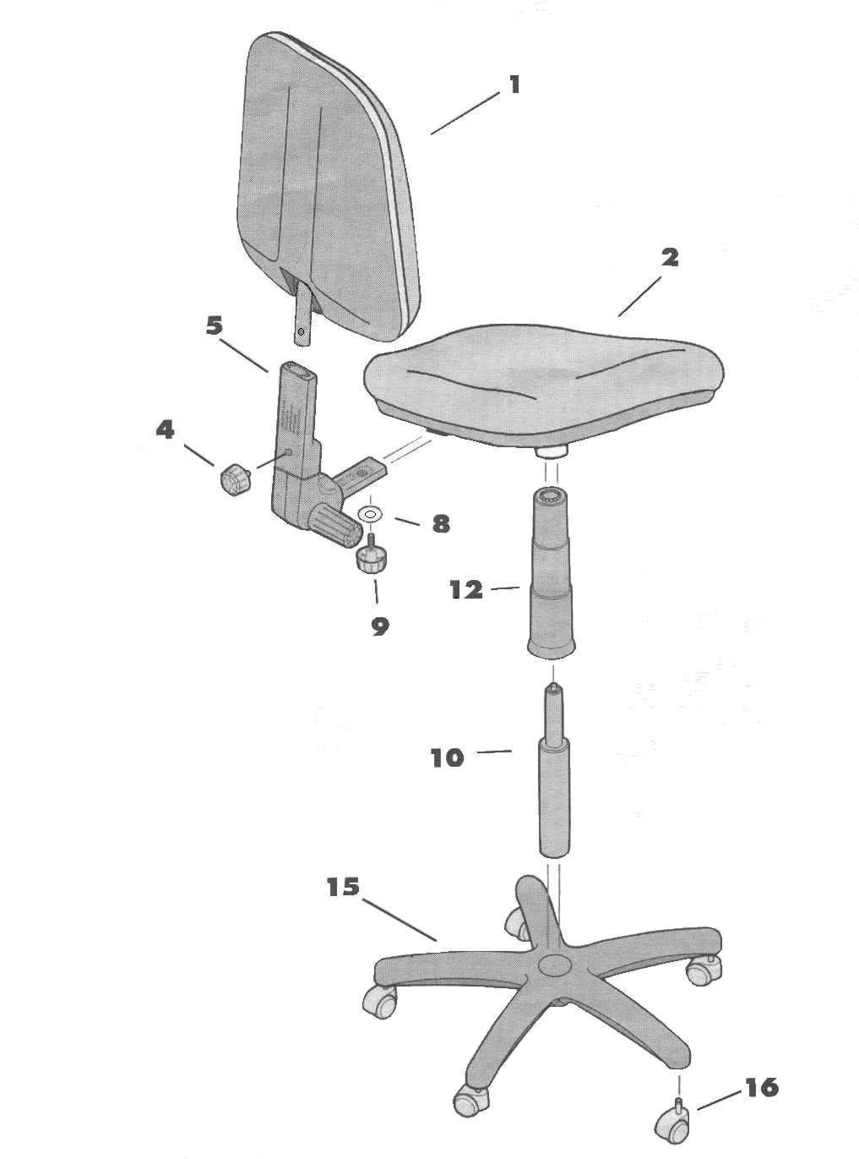

Components
Delar
- Backrest, ryggstöd
- Seat, sits
- Short screw, kort skruv
- Mechanism, mekanism
8. Metall ring, bricka
9. Long screw, lång skruv
10. Gas lift, gaskolv
12. Telescopic gas lift cover, gaskolvsöverdrag
15. Base, kryss
16. Wheel, hjul

